Work Update Report – React Props
Name: Palle Jyoshna
University: Mohan Babu University
Department / Course: MCA
Internship: Full Stack Developer Intern
Date: 24-12-2025
1. Topic
React Props – Passing data between components
2. Objective
The objectives of this task were:
- To understand the concept of props in React.
- To learn how to pass data from parent components to child components.
- To display dynamic data in components using props.
- To improve component reusability and structure.
3. Work Completed
✔ React Props Concepts Learned
- Props are read-only inputs passed to components.
- Props help in component communication.
- Data flows from parent to child component.
✔ Implementation
- Created a Student child component.
- Passed student details (name and course) from the App parent component.
- Displayed the passed data dynamically using JSX.
✔ Key Features Used
- Functional components
- JSX syntax
- props parameter for accessing data
4.Sample code
function Student(props) {
return (
<div>
<h2>Name: {props.name}</h2>
<p>Course: {props.course}</p>
</div>
);
}

function App() {
return (
<div>
<h1>React Props Example</h1>
<Student name="Palle Jyoshna" course="MCA" />
</div>
);
}
5. Output
- The application successfully displays:
  - Student Name
  - Course Name
- Data changes automatically when props values are updated in the parent component.
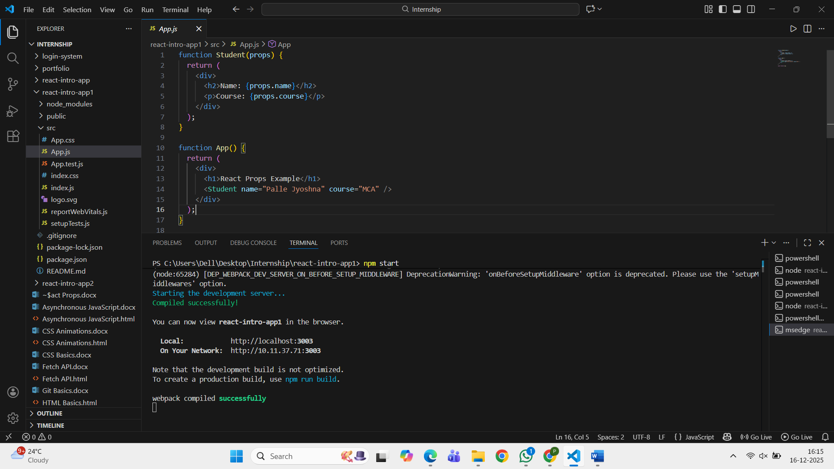
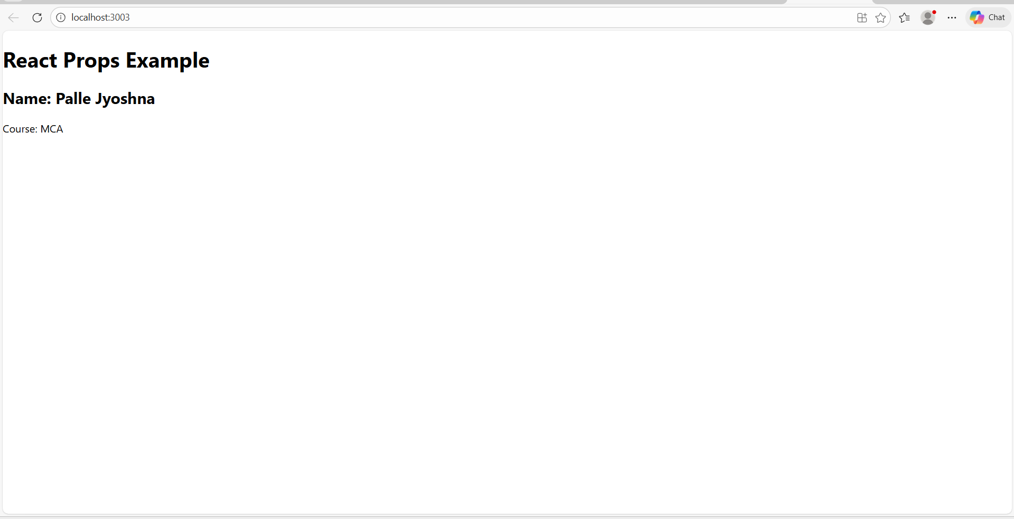
6. Conclusion
- React props provide an efficient way to pass data between components.
- Props improve code reusability, clarity, and modularity.
- Understanding props is essential for building scalable React applications.

